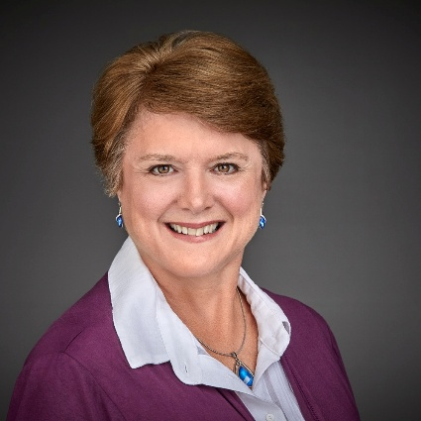





Speaking Topics
Available as keynote or interactive workshop

- Leading with Purpose as Your Business & Team Grow
- Confidence, Clarity & Courage: Leading Yourself So You Can Lead Others Well
- Calm, Clear & in Control: Emotional Intelligence for Leaders Under Pressure
- From Burnout to Sustainable Performance: How Leaders Can Protect Energy, Focus & Impact
- Communication
Catherine Rocheleau has appeared in:

Igniteleadership igniteleadership igniteleadership igniteleadershipinternational igniteleadership.blsky.social

CUTV News Radio
To Book Catherine:
1.604.813.5120
catherine@igniteleadership.co
catherinerocheleau.com
Award-winning Executive | International Speaker | International Best-Selling Author
Thought Leader in Leadership, Change, and Purpose-driven Performance
Catherine Rocheleau, MBA, VMP


“Catherine shared her vibrant energy, enthusiasm, knowledge & skills in leading change & moving the Board forward.”
M. Reyes, NutritionLink Services Society, Board Chair
“Catherine offers useful tactics, tips and tools to help you succeed. She is a class act & a true pro.”

Roger Killen – Serial Entrepreneur, Speaker

Catherine Rocheleau, (CEO & founder of Ignite Leadership International®) is an award-winning executive, author, and sought-after international speaker featured in the mainstream media including Fox Business’ “Worldwide Business with Kathy Ireland” CTV, CityTV and Bloomberg Television. She is recognized as a North American thought leader in leadership, change, and purpose-driven performance.

As a leadership and change strategist and through her signature SPARK™ framework, Catherine guides forward-thinking, human-centred leaders in moving through complex challenges, from uncertainty or overwhelm to being confident, focused, and committed to action — creating environments where work becomes a catalyst for growth, wellbeing, and lasting transformation.

Catherine lives in Victoria, B.C. & decompresses with walks in the forest or along the water. She is an avid sports fan of Vancouver teams and Team Canada. She is also a self-proclaimed Olympaholic.


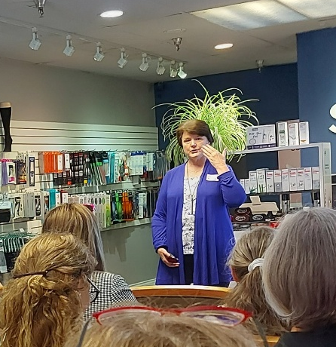
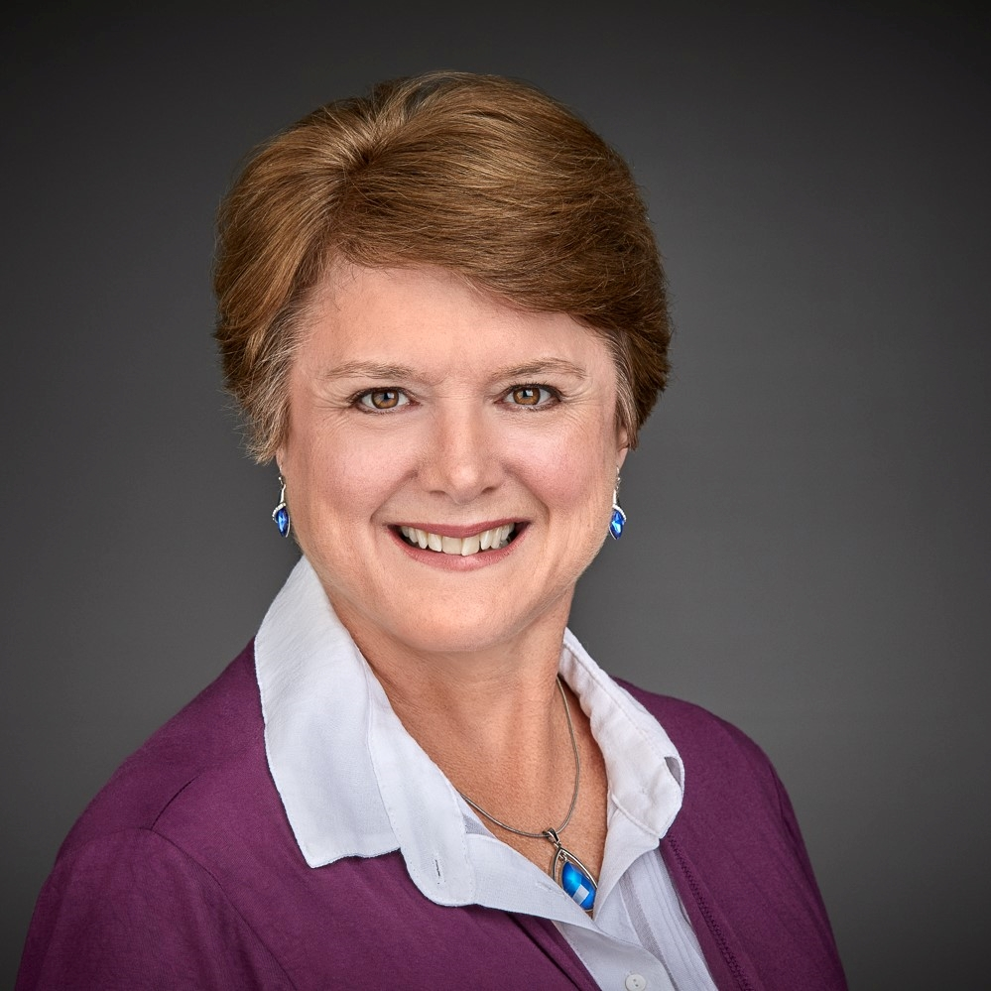
Guest Speaker on various podcast shows in Canada, U.S.A., Australia, Germany, Sweden
Traditional leadership approaches no longer work as they once did. Today’s leaders face greater complexity, change and unpredictability so they must interact with others and adapt to situations.

Relationships—not strategy—ultimately drive organizational success because they build trust and team involvement in the results achieved.
Many leaders view resilience as individual toughness. Instead, resilience is achieved in a culture where well-being, boundaries and belonging are embraced for everyone.
Human-centered leadership shifts the focus from solely financial and production metrics to placing a priority on people in every decision.
Emotional intelligence is critical for leaders today, especially in high-pressure environments. EI enables leaders to recognize, understand, and manage their emotions & empathize with others.
Contrary to many CEO surveys which claim leadership favors extroverts, introverted leaders bring unique strength and confidence & success to their role.
Catherine’s Keynote
The Human Advantage
Why People-Centered Leadership Drives Real Results
A compelling look at how leaders who prioritize people, clarity, and trust
consistently outperform those who don’t—without sacrificing results.

Audiences will:
- Understand why human-centered leadership is now a performance imperative, not
a “nice to have”.
- Learn how to balance business outcomes and human needs with sacrificing either.
- Walk away with practical ways to lead with clarity, trust, and purpose—especially under pressure,

Interview Topics

Igniteleadership igniteleadership igniteleadership igniteleadershipinternational igniteleadership.blsky.social

Distinctive Women’s Ignite Conference (Guest Speaker)
Flour Engineering Team Event (Guest Speaker)
Mom CEO Academy (Guest Speaker)
SPARK Leadership Conference (Guest Speaker)
Entrepreneurial Success Network (Guest Speaker)
Vancouver Business Network (Guest Speaker)
Kitsilano Business Network (Guest Speaker)
Capilano University – Staff Development (Guest Speaker)
B.C. Special Olympics Event (Guest Speaker)
University of Victoria (Guest Speaker)
B.C. Government (Content Expert, Guest Speaker, Trainer)
Canadian Food Services Executives Association Conference (Speaker)
Monsanto Canada Inc. (Content Expert, Guest Speaker)
Ultimate Women’s Conference – Colorado, USA (Guest Speaker)
International Business Network (Guest Speaker)
Dietitians & Nutritionists Association of B.C. (Guest Speaker)
Ashton College – Graduation Ceremony (Guest Speaker)
The Summit Event – Florida, USA (Guest Speaker)
University of British Columbia (Guest Speaker)
The Purpose-driven Leadership Summit – (Host & Speaker)
Featured Speaking Engagements

Total Social Media Reach = 7k

